**Filipe Santo**

**Code Smells**

1 - Dead Code

Location:

ganttproject/src/main/java/net/sourceforge/ganttproject/wizard/AbstractFileChooser.java

Explanation:

This function doesn’t do nothing, is a dead code, it should be deleted.

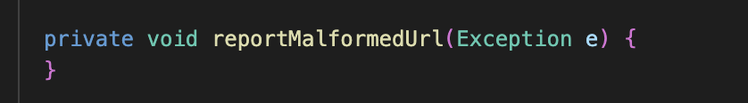

2 - Comments

Location:

ganttproject/src/main/java/net/sourceforge/ganttproject/client/RssFeedChecker.java

Explanation:

Instead of having the comments explaining the following complex expression, the expression should go to another function and make it name self explanatory. The comments should be deleted.

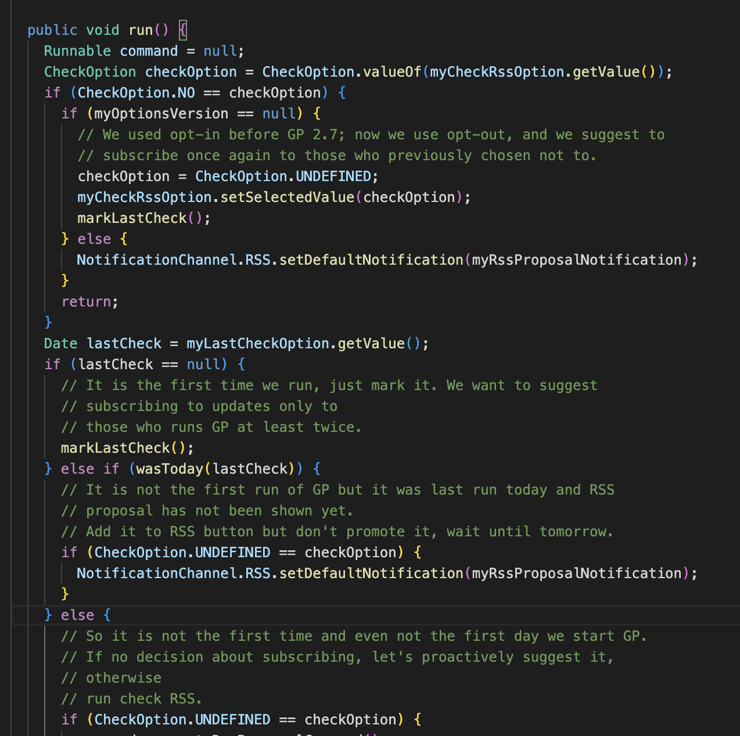

3 - Long Method

Location: ganttproject/src/main/java/net/sourceforge/ganttproject/GanttOptions.java

Explanation:

This method is very long with 204 lines. It should be divided into multiple methods and if possible follow the SOLID principles because it accumulates a lot of responsibility making it very hard to understand.

